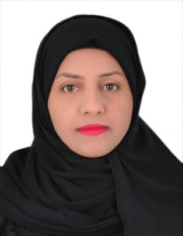

**CURRICULUM VITAE**

**personal Information**

***Name*  : fatema sayed haider**

***Date of Birth* : 18/5/1995**

***Nationality*  : Bahraini**

***CPR No*  :950504823**

***Religion* : Muslim**

***Sex* : female**

***Marital Status* : single**

***Contact No.* : 35113718**

**Email :falmosawii95@gmail.com**

***Address* : H: 918, R: 915 B:609 sitra**

**Education & Qualification**

**2008-2010 sitra intermediate school**

**2010-2013 sitra secondary girls' school**

**computer Skills**

* **Well in use Microsoft office**
* **Fast Typing in Arabic & English**
* **Good experience in common software packages: MS Windows, MS Office, Earth-Google, Map Source& Photo-Brush**

**Objective**

**I can work independently using my own initiative or as part of a team**

**Personal skills**

* **Adaptable to new technology**
* **Ability to work under pressures**
* **Able to work as a part team**
* **Effective communicational skills**

**Languages**

* **Arabic: Fluent – speaking & writing**
* **English: Good – speaking & writing**

**Experience**

**Orchid graphic 2015 to now**

**References**

**References available upon request.**